8.34: The initial momentum of the car must be the x-component of the final momentum as the truck had no intial x-component of momentum, so

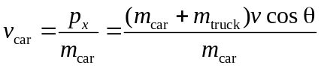
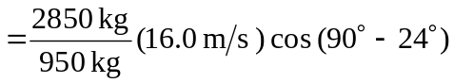
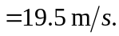

Similarly, 